Project Design Phase-II
Data Flow Diagram & User Stories

Date | 22 July 2026
Team ID | TEAM-HT-2026
Project Name | Heritage Treasures: An In-Depth Analysis of UNESCO World Heritage Sites in Tableau
Maximum Marks | 4 Marks

Data Flow Diagrams:
A Data Flow Diagram (DFD) is a traditional visual representation of the information flows within a system. A neat and clear DFD can depict the right amount of the system requirement graphically. It shows how data enters and leaves the system, what changes the information, and where data is stored.
Example: DFD Level 0 (Industry Standard)
Example: (Simplified)
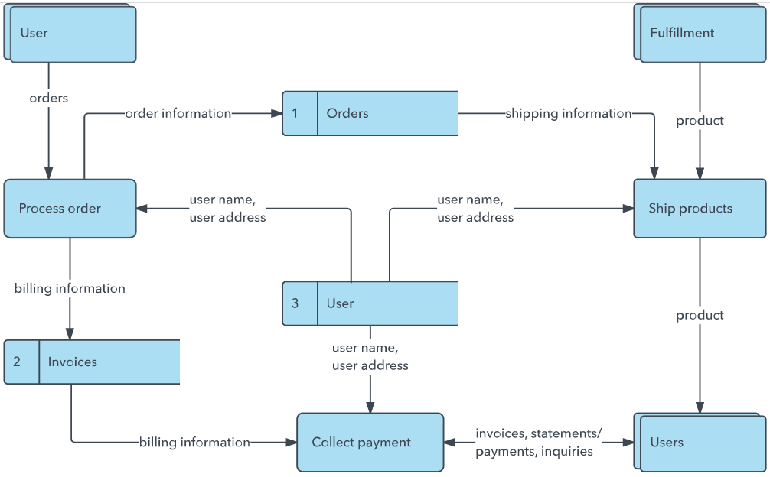


User Stories
Use the below template to list all the user stories for the product.
User Type | Functional Requirement (Epic) | User Story Number | User Story / Task | Acceptance criteria | Priority | Release
Analyst / End User | Data Access & Exploration | USN-1 | As an analyst, I can view a treemap of countries sized by number of heritage sites. | Treemap loads with correct counts per country from Country and Name_en fields. | High | Sprint-1
 |  | USN-2 | As an analyst, I can see a pie chart of sites 'In Danger' vs 'Not in Danger'. | Pie chart accurately reflects proportion using the Danger field. | High | Sprint-1
 |  | USN-3 | As an analyst, I can view a line chart of inscriptions per year, segmented by Region. | Line chart updates correctly using Date_inscribed and Region fields. | High | Sprint-1
 | Filtering & Interaction | USN-4 | As a user, I can filter the dashboard by Region, Category and Year range. | Selecting a filter updates all three visualizations simultaneously. | High | Sprint-2
 |  | USN-5 | As a user, I can hover over a country block to see the exact site count and site names. | Tooltip shows accurate country-level detail on hover. | Medium | Sprint-2
Tourism Board / Policy Maker | Story Navigation | USN-6 | As a policy maker, I can move through a guided story (Overview → At-Risk Sites → Regional Trends → Takeaways). | Story points navigate in order and each scene highlights the relevant chart. | Medium | Sprint-2
 | Data Quality | USN-7 | As a stakeholder, I trust that the dataset has been cleaned of duplicate or null entries before visualization. | No blank/duplicate Country, Region, or Danger values appear in any chart. | High | Sprint-1
Administrator / Developer | Publishing & Web Integration | USN-8 | As an admin, I can publish the workbook to Tableau Server/Public and embed it in a web page. | Dashboard and story render correctly inside the Flask-hosted page. | High | Sprint-3
 |  | USN-9 | As an admin, I can monitor how much data is loaded and confirm filters/calculated fields perform without lag. | Dashboard loads within an acceptable time with all filters and calculated fields active. | Medium | Sprint-3

Our Data Flow Diagram – Heritage Treasures Project
The Level-0 DFD below shows how data moves from the raw UNESCO dataset through cleaning and calculated fields, into Tableau visualizations, and finally to the published dashboard and story that end users and policy makers interact with.
